FINAL REPORT

MM1002 BREVIE

Bridging Reality and Virtuality with a
Graspable User Interface

Project co-ordinator
University of Bremen, artec
Prof. F. W. Bruns

Project of the Educational Multimedia Task Force (EMTF) Programme

financially supported by

ESPRIT (ESP)
Telematics Applications (TAP-ET)
Leonardo da Vinci (LdV)

Author: Dr. Volker Brauer (artec)

Date: November 2000

Version number: 3.0

Table of Content

1 Setting the Scene 3
1.1 Background 3
1.2 Challenge 3
1.3 Project Structure 4
2 Approach 5
2.1 Technology Development 5
2.1.1 User Participation 5
2.1.2 Requirements Analyses 5
2.1.3 System Design 6
1.1.4 Technical Solutions 7
1.2 Evaluation 8
1.2.1 Evaluation Objectives 8
1.2.2 Validation Sites 8
1.2.3 Evaluation Process 9
1.2.4 External Project Evaluation 10
1.3 Conclusion 11
3 Results and Achievements 12
3.1 The CLEAR Pneumatics Training System 12
3.1.1 The CLEAR Components 12
3.1.2 Telematic Application Aspects 14
3.1.3 General Application Architecture 15
3.2 Teaching Material 16
3.2.1 A Course in Basic Pneumatics 16
3.2.2 Further Training for Teachers 17
3.3 Psychological Evaluation 18
3.3.1 Hypothesis 18
3.3.2 Evaluation Approach 18
3.3.3 Evaluation Results 19
3.3.4 Conclusion 20
3.4 Product Commercialisation 21
3.4.1 Product Definition 21
3.4.2 Marketing Strategy 22
4 Conclusions and Future Plans 22
5 Contact Details 24

MM1002 BREVIE
Bridging Reality and Virtuality with a
Graspable User Interface

Giving students the chance to find their preferred way of learning is a challenge for trainees and trainers alike. Time and cost often prevent students from benefiting from the broad spectrum of media that exists to explore a particular subject. The learning environment ‘CLEAR’ (Constructive Learning Environment) developed by the BREVIE project integrates for the first time different learning media that can be used simultaneously
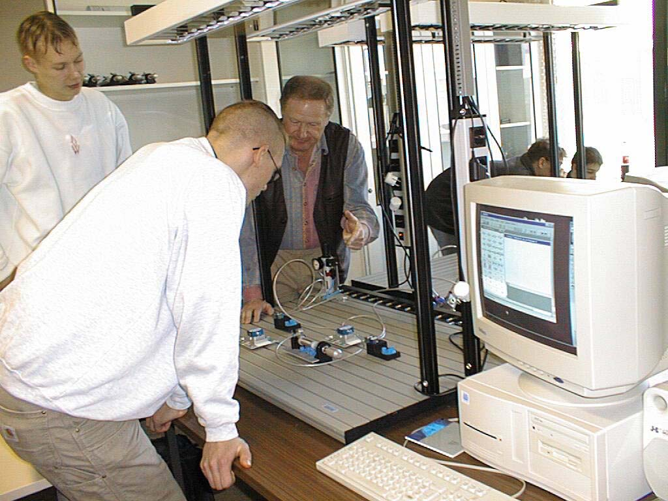
Setting the Scene
In vocational training for pneumatics one can find a range of learning materials. For the BREVIE project, the most attractive was the very popular pneumatic construction kit provided by Festo Didactic. This construction kit can be used for building functional pneumatic circuits that operate with compressed air and allow students to build simulated representations of real production environments. For building functional circuits, however, students need to learn underpinning theoretical knowledge about pneumatics. This is imparted by books, multimedia programs, simulators, and of course teachers. Based upon previous experiences of using computer based training systems ARTEC developed the idea of linking the practical and the theoretical parts of the learning process. Although this is a general concept, the project has focussed initially on pneumatics.
Approach
To realise and test CLEAR, the BREVIE consortium was assembled being made up of partners providing technical, pedagogical and psychological expertise. The technical approach was to make use of existing products and to link them to form a coherent unit. The main parts of the CLEAR system are the hardware construction kit for pneumatics (Festo); a digital simulator; an engineering drawing editor for pneumatics; and a virtual construction kit with 3D graphical representations and editor functions for pneumatic circuits. To realise the bridge between real circuits and a virtual representation consisting of a schematic engineering drawing and a 3D VR representation an image based recognition system is used. The 3D VR representation allows an alternative visualisation and further editing of the circuit.
In a user-driven development process two prototypes of the CLEAR learning environment were tested. The educational partners tested the learning environments through real courses in pneumatics. The courses were designed by the teachers involved in the project and standardised to ensure the comparability of the lessons. Psychologists evaluated the impact of the CLEAR learning environment, in terms of its impact on the learning process. The results from these observations were used to determine additional user requirements and to refine the system from a technical point of view.
Results and Achievements
The BREVIE project produced a new kind of learning environment for vocational training in pneumatics. A set of 15 CLEAR systems have been built and installed in five European countries. To test the systems in real courses, appropriate course material has been created. A total of about 200 students have used CLEAR. An intensive investigation about the effectiveness of CLEAR has been made. For this, a sophisticated psychological evaluation has been designed and implemented. The overall evaluation approach has been published and discussed with European experts. As such there is now discussion as to how this model can contribute to a standard used for the evaluation of computer based training systems.
Conclusions and Plans for the Future
The general concept of bridging real and virtually represented learning media proved to be technically and pedagogically innovative. It has been shown that it is helpful to integrate users early in the development process and to evaluate the concepts and developments by an independent party. In the near future prototypes will be prepared for the market. Technical refinements are necessary, and the scope of application must be extended from pneumatics to other subjects such as electro-pneumatics, hydraulics and mechatronics.

Contact Details
Project Name:
BREVIE - Bridging Reality and Virtuality with a Graspable User Interface
Research Area:
Vocational Education and Training, Advanced Training Systems
Timescale:
01.01.1998 - 31.3.2000
Budget:
Overall cost: 2 357 549 ECU
European Commission contribution: 1 561 604 ECU
Keywords:
Vocational Training, Advanced Training Systems, Virtual Reality, Augmented Reality, Simulation, Image Recognition, Human-Computer Interaction, Evaluation of Learning
Key Project Participants:
University of Bremen, artec (DE)
Festo Didactic GmbH & Co. (DE)
Superscape plc (UK)
Virtual Presence Ltd (UK)
Stockport College (UK)
Friese Poort Drachten (NL)
Escola Superior - IPL (PT)
Schulzentrum Im Holter Feld (DE)
ETH Zurich - IWP (CH)
Project Coordinator:
University of Bremen, artec
Prof. Dr. F. Wilhelm Bruns
Tel:+49 421 218 4206
Fax:+ +49 421 218 4449
E-mail: bruns@artec.uni-bremen.de
Project URL:
http://www.brevie.uni-bremen.de

Setting the Scene

Background
One main topic at the ARTEC research centre is the investigation, conception and development of simulation and multimedia systems in the field of industrial production and automation technology. A central question is how to preserve and make use of existing experience and skills when applying such systems.
Computers are used in the classroom as multimedia tools to provide sources of learning material, to provide interactive learning situations and to provide simulation of systems that for reasons of cost, size or safety cannot be used in the real world. One of the observable problems of using pure simulation tools, is that whilst learners can design and simulate correctly operating solutions to problems, they often have difficulties in implementing a real concrete model.
In the education and training sector the HYSIM project (Hypermedia Supported Simulation Systems for Vocational Training) had particular interest for the BREVIE project idea. In the course of this project various hypermedia systems were developed, applied in real school sessions and evaluated. There was a strong participation of teachers who played a key role in each phase of the project. One important finding was that hypermedia systems offer a great potential for the design and construction of learning environments. However, the teachers involved in the project always emphasised that such systems cannot replace the conventional forms of practical based education where trainees are faced with real machines and processes.
In learning we must take a number of concrete models and experience and form them into abstract concepts and ideas. Motivated by these results, the requirement to find sophisticated means of coupling physical and virtual artefacts was derived. ARTEC initiated various projects to investigate the possibility of coupling real physical worlds (models and components) with virtual worlds. It is believed, though not verified at this stage, that the ability to forge bonds between abstract and concrete ideas is one of the keys to provide students in vocational training with an adequate learning situation.
The domain of pneumatics as a basic technology frequently used in automation technology was chosen for various reasons. Most importantly pneumatics is appealing to students because of its mechanical forces and acoustic sounds provoked by the compressed air when pneumatic systems are built. On the other hand pneumatics as an engineering discipline requires symbolic knowledge such as the ability to create engineering drawings and to understand the behaviour of dynamic systems.

Challenge
By bridging the gap between the real world and the virtual world, links between abstract and concrete representations may be established. The use of concrete components gives learners the feel and experience of the real world. The use of 3D visualisation and schematic representations mean that links can be made between the concrete and abstract concepts required for learning. The use of computer technology means that information in audio, video and schematic form amongst others, can be made available to the learner. To achieve this bridge a new interface is required that can translate the construction of a concrete world into an abstract representation. For the pneumatics application this means that pneumatic circuits built with a construction kit can be recognised by the computer and represented as VR models or schematically as engineering drawings.
The students will use the computer to provide information about pneumatic components in terms of their functionality and their application in a practical context. Although such a learning environment is complex by nature, it must be useable by students with little computer experience. Also it should not take significant time to learn how to use the training system.
Beyond the technical challenge new pedagogical concepts are required. With the new learning environment the role of the teacher changes from that of the traditional lecturer. The teacher acts as a resource, providing support and information for the students as required by them. The teacher must guide the learner through the learning situations and assess their level of understanding and competence. The teacher must also provide guidance in the use of the equipment and tools available to the students. These concepts have to be tested and evaluated in real learning situations. Only through this evaluation can a deeper understanding of the effectiveness of both the medium and the learning concept be gained.

Project Structure
To meet these challenges the project required technical competence in fields such as multimedia, human-computer interaction, simulation or virtual reality, and strong user participation and feedback during the development process. To achieve this a prototyping strategy was implemented. In the first year a prototype of the learning environment was constructed which was delivered to test partners. The educational partners (Stockport College, Friese Poort Drachten, Escola Superior, Schulzentrum Holter Feld) used the prototypes in training courses. A sophisticated evaluation process undertaken by partner ETH Zurich accompanied the test phase. The courses were observed, users were interviewed and data was collected using questionnaires. The data was analysed and provided important input for the further development of the learning environment.
The co-ordination of all system development activities was done by University of Bremen, ARTEC. The architecture of the system consisting of many modules such as a simulator, visualisation, multimedia databases and a number of hardware parts was agreed between all partners involved through technical questions. Partner Festo Didactic produced a hardware construction kit for pneumatic systems. Partner Superscape designed 3D models of pneumatic components suitable for the use in Internet applications, and a 3D editor for pneumatics was provided by partner Virtual Presence.
A second trial with an updated training system and an optimised evaluation process was undertaken to verify the hypotheses about the learning environment and the pedagogical concepts. With this concluding milestone a foundation for both the further research in this field and the commercial exploitation of the project results was laid.

Approach

Technology Development

User Participation
The project paid special attention to users (teachers and students) and their views played an important part in the project. Users discussed and formulated system requirements in close co-operation with the developers. They were involved in installation tasks, they reported difficulties with using the system, and the made valuable suggestions for improvements. With their background knowledge about the learning environment teachers defined the content of the courses and chose students for the evaluation. The permanent involvement of users was identified as a key issue for the system development. Teachers from all validation sites took part at all project meetings, and there was continuous information flow via web-based communication tools. The most effective kind of user participation, however, was the evaluation of the prototype learning environments. In collaboration with all user sites, an evaluation plan was designed to get detailed insight into the system and its usability in real test environments.

Requirements Analysis
The requirements for the CLEAR learning environment were derived from an analysis of the current practice in educating students in pneumatics. This practice is characterised by teaching and learning different skills and knowledge supported by a variety of media. CLEAR, as it is an integrated system, was required to support a set of interactions (use cases:
- Building pneumatic circuits on a base board
- Creating circuit diagrams
- Analysing the functionality of a circuit
- Getting information about pneumatic elements
- Comparing pneumatic circuits of different students over the network
- Checking circuits - the teacher can remotely access the virtual model of a circuit
These use cases were further investigated and specified. In co-operation with the teachers a set of exercises students usually have to do was specified. The CLEAR system was designed to cope with a complexity of circuits normally used for a beginner’s course in pneumatics.
The result of this specification phase was a set of functional requirements for the CLEAR system. The requirements analysis document described in detail the core functionality of the system from the users point of view.
Because it was recognised that the usability of a training system is particularly important for its effectiveness, attention was focussed on this issue. When testing the prototypes, students were asked to fill a usability questionnaire and to suggest improvements. These were considered in the further development of CLEAR.
From the beginning, the project spent a great deal of effort in meeting the economic requirements of the partners wishing to commercialise the results. Most importantly, Festo Didactic calculated a cost limit for the CLEAR product. This had a strong impact on the development of CLEAR. It was decided to reuse as much hard and software products already available as possible, and, if possible, to make use of low-cost components.

System Design
Some key components of CLEAR were already available before the project started. However, they had to be modified and extended to fit the general design concept. The Festo TP 100 Construction Kit for Basic Pneumatics was chosen as the starting point for creating the Hardware Construction Kit (HCK) of CLEAR. The Festo interactive digital fluid dynamics simulator FluidSim-P was chosen because of its functionality in simulating pneumatic circuits and making engineering drawings of pneumatic systems. Furthermore, it provided a multimedia database of pneumatic components. Although this was just a starting point, TP 100 and FluidSim already embodied the basic idea of coupling a conventional hardware-based construction kit with a symbolic simulator. The main development task of the project was to create the ‘missing link’ between these products. Based on previous research of partner ARTEC, the idea to create another key component called ‘Universal Graspable User Interface’ (UGUI) was born. This interface should be capable of tracking the user actions with the hardware kit and to map them to a virtual model stored in the computer. The terms ‘universal’ and ‘graspable’ underlined that the concept as such was thought to be open for a variety of input devices like data gloves or video cameras. Thus, the UGUI can be considered as an abstract layer between the physical reality where users act and a virtual model on which the computer operates.
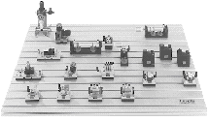
Festo TP 100 Product
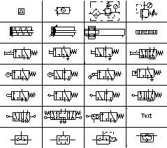
FluidSim-P Symbol Library

The need for the user to view a diversity of representations of one and the same model (in this case a pneumatic circuit) was the motivation for creating another key component ROMAN (Real Object Manager). ROMAN is used for generating and managing different views of a single digitally stored model. Again, this concept and first implementations came from previous research of partner ARTEC. Although not available at this stage, with the abstract component ROMAN in the background it was quite simple to integrate more components into the system. As required by the users, CLEAR should provide 3D graphical models of circuits. The Virtual Construction Kit (VCK) was designed as a software module to be connected to ROMAN and thus receiving all necessary data for 3D editing and visualisation of pneumatic circuits. Because of their expertise in VR-projects the VCK was developed by partner Virtual Presence. Some important functions of CLEAR require a network access to the data maintained by ROMAN. This is also the case with the ‘Web-Plugin’ that was designed to allow remote access to virtual models with Internet Browsers. Since the communication protocols of ROMAN were IP-based, the development of the Web-Plugin by partner Superscape required the implementation of the protocol instructions in their 3D-viewer product Superscape SVR.™
In summary it may be said that the CLEAR learning environment was built from a number of components (hard- and software) that partly existed before the start of the project. The main development challenge was to create a framework that allowed a complete integration, and through this enable the users to develop and use their own learning styles.

Technical Solutions
According to the prototyping philosophy the technical development started with a design sketch for the envisioned product. It was recognised that the spatial layout of the hardware components would be crucial for the usability of CLEAR. Like conventional construction kits for pneumatics, CLEAR needs a modelling desk to support the base board on which the pneumatic elements are placed. This arrangement provides enough space for small groups of students to work co-operatively. They can stand in front of or beside the modelling desk. If they want to conduct experiments using virtual models or the simulator they can shift their focus to the computer screen for which there is some space on either side of the desk.
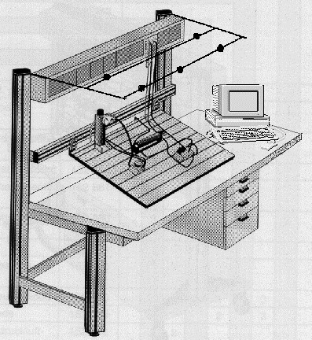
Design Sketch of CLEAR
A key issue was the realisation of the technical bridge between the real world and its virtual model. It is through this link the students should get access to simulation and multimedia help information. At the beginning there was a variety of possible solutions to this problem. ARTEC had some previous experience with VR-devices such as data gloves and tracking systems that can be used to recognise user actions in real space. Unfortunately the state of this kind of technology proved to be unusable for two reasons: special operating conditions are required which cannot be realised in practice; and high costs. The alternative was to use an optical system to recognise the circuits built on the baseboard. Investigations to find the most suitable number of position of camera devices were carried out. Different solutions such as placing the recognition devices under the table, or building an array of cameras to increasing the image resolution were discussed. Finally it was decided to use two low cost colour CCD-cameras mounted on a rig so that they ‘look down’ on the baseboard. This was the cheapest and the most feasible solution.
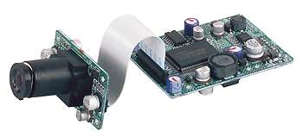
CCD-Camera used with CLEAR
In the project there was an important discussion concerning the telematics aspect of BREVIE. The peer reviewers also had a decisive influence on this aspect of the project (see also next section). Although it was planned to link different CLEAR-workstations over the Internet and to make experiments with cross-national lessons, the reviewers recommended downsizing the complexity of the project due to the level of technical innovation in the rest of the project. Even so, the technical architecture allows network operation and the core functions were implemented to demonstrate the feasibility of this functionality. In the final system, CLEAR is has the technical infrastructure to be further developed as a tele-teaching system. It contains an application for editing 3D pneumatic components with a web browser, but in the course of BREVIE it was primarily used in the stand-alone mode.

Evaluation
Like the technical development, a two-phase strategy was implemented for the project evaluation. Technical recommendations were derived from an evaluation following the delivery of the first prototype. Using the improved prototype, the subject of the second evaluation phase was the effectiveness of CLEAR in terms of the learning output and its operation. The fact that the evaluation was an integral part of the project was complemented by reviews of external experts. This section outlines the evaluation approach used in the project.

Evaluation Objectives
In the design process of the BREVIE project evaluation was an integral part. It was used as a supporting measure to keep the project on the right track in achieving its aims and to redefine the aims if they turned out to be unachievable or inappropriate. In this sense the evaluation approach is rather more formative than summative. In addition to this general function there were a number of evaluation objectives concerning CLEAR:
- obtaining insights into the potential and limitations of the new learning environment in terms of its user-friendliness and suitability for learning,
- investigating pedagogical and teaching aspects of using CLEAR,
- analysing the psychological processes of students using or learning with CLEAR,
- evaluation of the evaluation approach itself. Is the evaluation design appropriate?
In addition to the internal evaluation the project was subjected to external reviews. A board of experts, either visiting the project on-site or reviewing the project results formally, considered the development at regular intervals. After each review the experts made recommendations that impacted on the future course of the project. The main objectives of this kind of evaluation were to offer the project independent views on its work and to provide the Commission insight and influence over the project.

Validation Sites
The main user groups the BREVIE project was aimed at are students and teachers in education and training for automation technology. The BREVIE consortium had a strong involvement of vocational school and college partners. They had a significant impact on the design and technical realisation of the CLEAR system. In addition to the teachers and students involved in training courses it was considered important to get information about the prospective customers of the CLEAR product. To support this a lot of information was produced, the prototypes were demonstrated at various occasions, and the European product managers of partner Festo were invited to a workshop on CLEAR to discuss the chances of such a product reaching the education and training market.
Four school partners were involved in the evaluation of CLEAR. A fifth partner undertook the development and implementation of the psychological evaluation concept. The schools and roles are detailed below.
- Stockport College, England: trial courses in basic pneumatics, co-ordination of school partners, management of pedagogical tasks and workpackages,
- Friese Poort Drachten, The Netherlands: trial courses in basic pneumatics,
- Escola Superior de Technologia e Gestao de Leiria - Instituto Politecnico Leiria, Portugal: trial courses in basic pneumatics,
- Schulzentrum Im Holter Feld Bremen, Germany: trial courses in basic pneumatics, direct contact point for developers in Bremen,
- Eidgenössische Technische Hochschule Zürich - Institut für Arbeitspsychologie, Switzerland: psychological evaluation of trial courses, evaluation design, development of evaluation instruments, on-site evaluation, video observation, final analyses.
Trial courses in basic pneumatics took place at each validation site. It was planned to deliver the courses with a group of 24 students at each site. Thus, considering that CLEAR was evaluated twice, a total of 2 x 4 x 24 = 192 students were intended to take part in the evaluation.

Evaluation Process
The agreement of an appropriate evaluation process to provide the information needed for a serious scientific analysis was a major task of all parties involved in the project. A quasi-experimental design was considered to be most adequate. The main factors of the evaluation process implemented in BREVIE are the: learning environment, users and teaching units.
Learning environment
Three different kinds of learning environments were used by the students: the conventional Festo construction kit with physical components, the computer with a simulator and integrated multimedia functions, and the CLEAR system consisting of a combination of the hardware construction kit, simulator and multimedia system. The lesson plan was the same for all learning environments, to ensure the comparability between the different environments.
Users
To compare different learning environments it was essential to have students with the same profile. The properties of this profile consist of: knowledge in pneumatics, technical background, gender, age or motivation. For the selection process students they were invited to take part in a project. They were asked to take a pre-test, and based on the results they assigned to comparable experimental groups. Each group took part in a course in pneumatics using only one type of learning environment.
Teaching units
The course was designed to be an introductory course to pneumatic systems, and the profile of students used in each site was that they have no prior knowledge of pneumatics and some technical background. The course was set to be 16 hours long culminating in 2 x 60 minute tests (1 hour theoretical and 1 hour practical). The purpose of the test was to provide feedback to the students and to provide data to evaluate the learning. The theoretical test was also taken before the students studied the course. This provided a base line measurement of their knowledge.
This extensive evaluation approach was timed in distinct phases of the project. It took about six weeks from the first lesson at the first validation site to the final knowledge test at the last site. During this time the evaluator travelled to each site, made interviews with the test persons and collected data using questionnaires and/or video observation. The results achieved by the analyses of the evaluation process will be discussed in section 3.3.

External Project Evaluation
The project was reviewed by external experts. Two on-site reviews took place, the first one at partner ARTEC in Bremen (Oct. 1998) and the other one at Friese Poort College in Drachten, Netherlands (Sept. 1999). The formal Annual Review took place in Brussels (Jan. 1999). The feedback and recommendations the project received was constructive and helpful. The following categories summarise the outcome of the external project evaluation:
- Management Measures: The project suffered delays with the creation of a consortium agreement on IPR. Only following demands from the reviewers did project members start work on it. The same was also true of the exploitation plan for CLEAR. The project needed the impetus and demands of the reviewers to approach this issue systematically.
- Evaluation: Although the reviewers commended the psychological evaluation, their comments and views had an impact on its implementation. The evaluation was focussed on the learning environment and the students who used it. It was recommended that the investigations also involve the tutors. In particular it was recommended that the evaluation involve tutors who were not part of the project. Furthermore, it was required that the evaluation consider the long term effects of CLEAR, and possible side-effects like deskilling in respect of making engineering drawings because of the automatic generation function.
- Project Presentation: At the beginning the project members had heterogeneous styles of presenting the project objectives and results. To make a commonly used presentation was a good advice and was worthwhile for later demonstration. The reviewers also suggested the idea of making a video for the project. Because of the complexity of CLEAR and the context of use it was hard to communicate the ‘messages’ of BREVIE. This was much easier once the project video was available.
- Project Strategy: Two issues had a major impact on the general project strategy: the role of distance learning and the expansion of project focus from pneumatics to other applications. Considering that the project received telematics programme funding and that the project proposal made reference to the use of internet, but the nature of CLEAR was mainly a ‘local’ concept, a decision regarding the actual product was required. Taking into consideration the pedagogical and technical arguments and the suggestions of the reviewers to focus the efforts on a local learning/teaching application, the consortium decided to limit the use of CLEAR to local applications. With regard to the focus on pneumatics the consortium investigated the possibility of adapting the same concepts for similar applications such as electro-pneumatics, hydraulics or mechatronics. On the technical level the system was prepared to replace the pneumatics construction kit with other ones.
Other forms of external input were also useful. In general the project received positive feedback from demonstrations at exhibitions and congresses. People who are involved in education and training in automation technology welcomed the idea of combining physical and virtual learning media. This was also found to be true when talking to business people. From their point of view the project learnt to keep an eye on the costs of the product. Therefore, quite early in the project it was decided make use of low-cost or off-the-shelf components if possible.

Conclusion
The BREVIE project idea addresses the pedagogical requirement of combining various kinds of learning media in a single learning environment. Constructive Learning emphasises the importance of associating abstract knowledge with physical effort. Thus, the main innovation which is embodied by CLEAR is to provide direct links between learning with physical, functional pneumatic circuits and computer based representations like symbols, engineering drawings and schematic views.
The technical concept of CLEAR is based on the (re)use of available and well tried and tested components. What already existed when the project started was extended and prepared for its combination with other components. Through this, a complex technical system was created. Thanks to the expertise of the different developing partners and because of the clear software architecture, the resulting prototypes were successfully used in trial courses.
User participation and the evaluation of the project results was an integral part of the project. The results produced from the tests made under realistic conditions directly effected the development of CLEAR. The involvement of school partners not only had important outcomes in terms of user requirements but also produced a large empirical database for psychological analysis. In addition to this the teachers created a common course in pneumatics, including course materials and tests, which was used in four European schools and colleges.
The BREVIE project was the subject of several reviews carried out by experts and delegations of the European Commission. The recommendations and comments of the reviewers were helpful and had significant impact on the ongoing work. Additional feedback from other sources underlined the view that the project was anxious to disseminate its results. Moreover it was open to new ideas and always keen to put them to use.

Results and Achievements

The CLEAR Pneumatics Training System
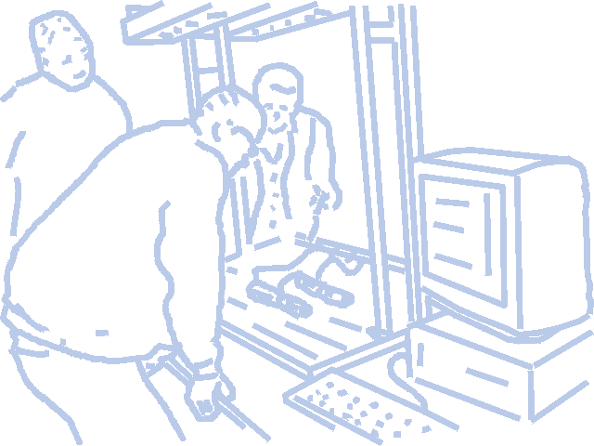
The CLEAR Pneumatics training system combines real equipment with 3D virtual reality. It allows students to build pneumatic circuits using real components, which can then be scanned into a computer to produce two-dimensional schematic diagrams or 3D virtual reality circuits, on which tests and simulations can be undertaken. The system uses bar-coded pneumatic components that can be laid out as a circuit on a baseboard. Two cameras mounted above the board scan the circuit. The computer software identifies the components from the bar codes and creates a virtual reality version of the circuit, drawing on information from its component database. The database contains a 3D model of each of the components, a description of their function, and their specifications. This can be used as a help facility by students. The use of actual components gives the student the feel and experience of the real world, and using 3D visualisation and schematic representations mean that links can be made between the real and abstract concepts required for learning.
The complete CLEAR system has the following features:
- CLEAR integrates physical and virtual learning media in a single environment
- CLEAR allows the construction of circuits using multiple double acting and
single-acting cylinders
- CLEAR allows the construction of circuits using logic functions
- CLEAR allows the construction of circuits using time delays and switches
- CLEAR provides help information on all available components
- CLEAR provides schematic representations of circuits
- CLEAR provides 3D visualisation of circuits
- CLEAR recognises components with a minimum level of IT skills required by users
- CLEAR allows the use of software simulation
- CLEAR supports learning in groups
- CLEAR works with standard PC hardware and the MS Windows NT operating system
The system structure is modular. The complete learning environment can be built from individual components like the simulator, the visualisation module or the hardware kit.

The CLEAR Components
The CLEAR Pneumatics training system consists of several components, each of them embodying a distinct set of functions.
The Hardware Construction Kit (HCK)
The HCK consists of a set of components which can be used to build functional pneumatic systems. Most of these components, for example cylinders and valves, are also used for industrial applications. The conventional hardware set-up was modified to implement the automatic recognition of the circuits. A gantry was mounted on the base plate. The gantry holds lightning devices and two cameras which ‘look’ down on the plate where the students build the circuits. The components as well as the tubes were marked with a colour code. The code is used to identify the type of component. When the students trigger the recognition process the CLEAR software identifies the components on the board and draws links between components according to the tubes connecting the components. In this way the system creates a virtual image of the circuit on the board. On a computer screen placed behind or on the side of the board the students can see the virtual circuit.
The hardware circuit can be operated with compressed air. Whenever they want the students can turn on the pressure and immediately see the behaviour of the circuit. If they have made mistakes whilst building a circuit, for example leaking connections, they can hear how the air escapes. The force of the air under pressure is also perceivable. Moveable parts like the piston of a cylinder can hardly be stopped with the hands when they move out with a pressure of six bars. These properties are very difficult to simulate with a computer.
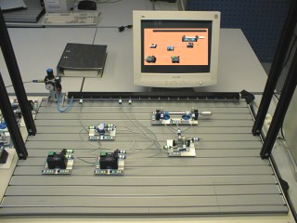
The CLEAR HCK with a virtual
scene in the background
The Virtual Construction Kit (VCK)
The Virtual Construction Kit contains the same set of pneumatic components in a library of three-dimensional graphical models. Much effort was spent to make the 3D-models very similar to their real counterparts. Otherwise the students would have to learn another form of representation, which in practice never occurs. The students can navigate in the 3D virtual circuit by using navigation features of the VCK like the free mode or fixed view points. In the edit mode the students can modify the circuit, they can insert new components, delete them, or draw connections.
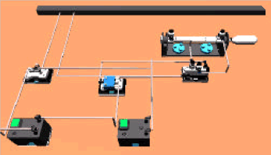
3D View of the VCK
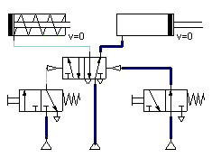
Schematic View of the VCK
An important part of the VCK is the simulator FluidSim and the integrated editor for engineering drawings. With conventional Drag & Drop interactions the students can create engineering drawings with components they take from a standardised symbol library. The schematic view is closely coupled with the 3D view. Whenever either of the views is changed in the edit mode, the other one is automatically updated. This way the students have a direct mapping between the different levels of representation they have to learn. However not only static circuits can be seen in two different views. When the circuit is in the simulation mode the dynamic behaviour is visualised in both views, that is, the students can see the behaviour of the circuit in the schematic and the 3D view as well. The simulation mode can be used as a tool to find errors in the circuit. The flow of the compressed air through the circuit is visualised, so the students can see which parts are supplied with air, depending on the state of the circuit. For example in the trace mode, the students can follow the state of each component in a stepwise fashion.
The Multimedia Help System
At the beginning of the course the students are not familiar with pneumatics and the components used in this technology. On the other hand they are faced with them when make practical exercises. To recognise and to learn the functionality of the components, however, is essential for understanding pneumatic systems. CLEAR contains a computer based multimedia help facility that provides rich information about each component. This help system was designed specially for BREVIE. It arranges textual, symbolic and graphical representations in a single window. In addition, the students can play movies explaining the working principle of a component. Since problems often occur when the students build real circuits, two methods of invoking context sensitive help were implemented: a ‘help area’ on the base board and a pointing device. In the help area students can place a component and then trigger the help function. The component is then recognised and the help window displayed on the computer screen. With the pointing device the students can point at any component on the board. When the device is pressed on a component surface a LED on the device lights up and CLEAR recognises the component the student is pointing to. Again the corresponding information is displayed.
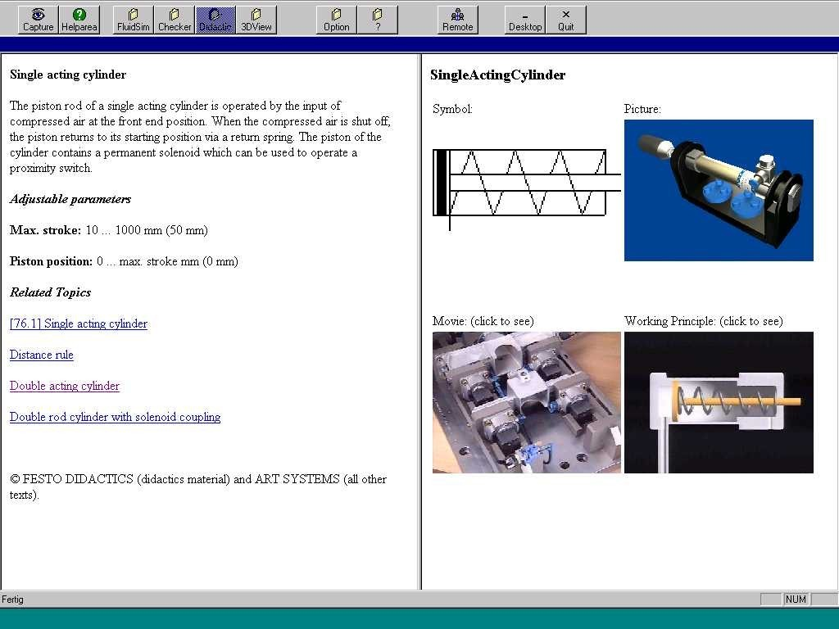
CLEAR Component Help Window

Telematic Application Aspects
The CLEAR system as described so far is limited in that the students must be at the same physical location as the hardware. In the course of the BREVIE project the possibility of producing an internet delivered viewer, such that remote users may connect to a web site and view the operations being performed on the BREVIE system, were investigated. Two possible solutions were considered: a ‘static’ and a ‘dynamic’ link of remote clients with the virtual model maintained by CLEAR. The static solution makes a snapshot of an actual state of the virtual model, then a scene containing all components and tube connection is created, and finally this scene is downloaded to the remote computer where the user can view and navigate the scene. The dynamic solution is more sophisticated. A permanent communication link notifies the remote client(s) about changes on the central virtual model. For example, if a new component is created in the VCK, remote users can trace this action. Both solutions were realised using the Superscape SVR software. With a Superscape Browser Plugin - available for free for Netscape or MS Internet Explorer web browseres - remote users can access actual learning sessions running on the CLEAR server platform. Since the Web-Plugin was planned to be a technical feasibility study it was not evaluated in real classroom sessions.
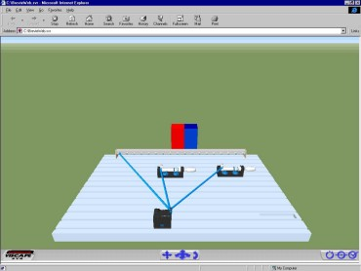
Web-Plugin for accessing CLEAR

General Application Architecture
A look behind the user interface shows that another important outcome of the BREVIE project is the technical application architecture. It was essential to find a way of integrating various existing products and solutions in a single framework. Furthermore, the solution needed to be adaptable for other applications. The basic idea was to implement a client/server model, where some software components act as service providers and are used by client components.
The figure shows the main components of the CLEAR system. The most important service module is the ROMAN (Real Object Manager). It is the only software component which can change the model database directly – this is where the virtual pneumatic circuits are stored. The other components such as VCK or the Web-Plugin access the model through the ROMAN by using communication protocols with a defined set of commands. The clients themselves might also act as service providers. They can offer functions for other components (not visible in this figure). For example, the UGUI is a server because it supplies the ROMAN with event messages from the input system.
The communication between the client applications and the ROMAN is implemented using TCP/IP socket connections. The partners involved in the software development agreed upon a network protocol that connects the client applications to ROMAN. The TCP/IP protocol was extended by several supplementary protocols. With them it is possible to transfer scene graphs (abstract data representations of pneumatic circuits) over the network. To modify scene graphs the protocol contains a defined set of commands that can be used by programmers of client software. Apart from the TCP/IP standard, ROMAN uses VRML 97 for representing scene graphs. Through using this format, a wide range of software, for example Internet browsers, is compatible with the application architecture developed in BREVIE. The client/server solution in combination with the protocols provides the possibility of running the CLEAR system as a network of communicating software agents. Each agent offers its services to ROMAN and can make use of the services of other agents. ROMAN then manages the event-routing between service-providers and service-users.
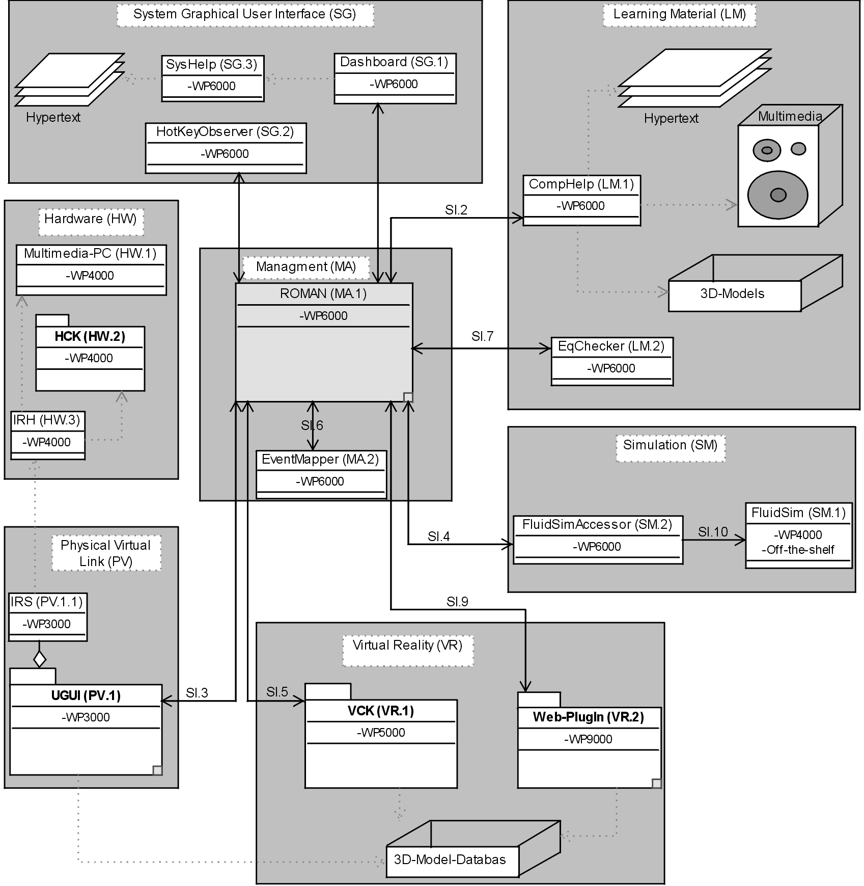
The CLEAR Application Architecture
This architecture is context-free, that is, there are no dependencies within the application domain, for example ‘pneumatics’. Therefore, the software developed in BREVIE can be reused for other applications that need to maintain virtual models representing topological structures.

Teaching Material
The use of CLEAR in the context of education and training together with the plan to deliver trial courses with students and a psychological evaluation required detailed preparation. The user sites involved in BREVIE did not only test the training system. In addition they had to develop course materials that made use of CLEAR and develop tests to evaluate the properties of the system.

A Course in Basic Pneumatics
The CLEAR training system was used for a vocational training course in basic pneumatics. The courses took place twice at each evaluation site, the first time in 1998 with the first prototype and the second time in 1999 with a significantly improved version. A thorough preparation was necessary to make sure that the courses ran smoothly under scientific conditions. This work was organised in one work package that produced important results:
- a teaching plan
- a student workbook
- assessment material
- a teaching schedule
The teaching plan is the most important document. For the evaluation to be effective the teachers at each of the four evaluation sites were required to deliver the course in a very similar way. Students must be given the same level and style of help and have access to resources in a similar way. The teaching plan aims to address this need by providing a detailed documentation of the teaching sessions, activities of the teacher and activities of the students.
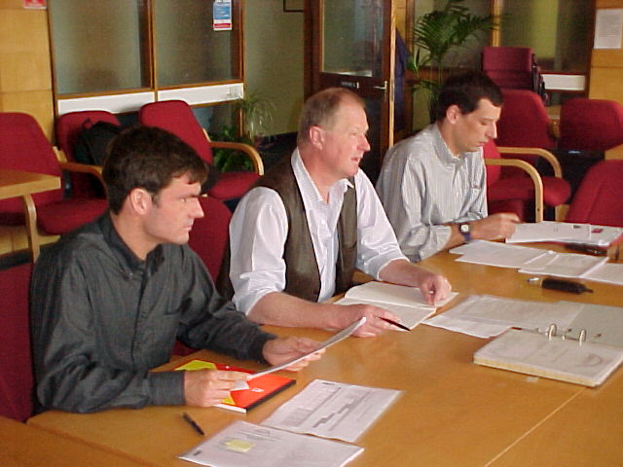
Course Preparation at
Stockport College, June 1999
In conjunction with the teaching plan, students use a workbook to record their results and activities. The workbook is structured so that students receive it one page at a time with each page giving the students details of the task or activity.
After completing the courses the students were asked to take various tests. The teachers developed the assessment material to examine what the students had learnt during the course. The assessment consists of two parts, a theory test and a practical test. The theory test was sat by all the students at the start and end of the course and was designed to test knowledge gained in pneumatics. The practical test was sat only at the end of the course and was designed to test knowledge of pneumatics and problem solving skills.
The piston of Cylinder 1.0 goes out with full force when:
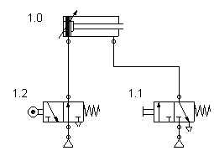
a) you push at 1.2 and not at 1.1
b) you push at 1.1 and not at 1.2
c) you not push at 1.2 and not at 1.1
d) you push at both (1.1 and 1.2)

An example question from the assessment material
The teaching schedule shows the order in which the student groups are taught. The schedule was determined by the need to give continuity of teaching to the students and also to allow the evaluation team access to the students at the appropriate points.
The student workbooks and all the assessment material has been translated into the native language of each application site.
This course material complements the technical work. The teaching plan, the student workbook as well as the assessment material can be considered as additional product features of the CLEAR system.

Further Training for Teachers
Another important outcome of the work package concerned with the pedagogical aspects of the project is a programme for the further training of teachers who will use the CLEAR system in their courses. The staff development programme is intended to show the user the operation and potential application of the equipment in a classroom environment. Primarily the CLEAR equipment is intended to be used with teacher support and teachers will need to be aware of the features and limitations of the equipment. The staff development programme covers the features available within the system.
The aim of the programme is to provide the learner with effective training in the use of the CLEAR hardware and software for the design, construction, testing and running of circuits. At the end of the programme the learner shall be able to use the facilities of CLEAR to support their own teaching and the learning of their students.
The training programme provides 6 hours training in the use of the system and is scheduled to consist of three sessions comprising one complete day. The basic concept is that during the sessions the trainer will take the learner through a series of practical tutorials and examples demonstrating the operation of the system and how it can be used to support teaching and learning.
In the finalised product version of CLEAR, some form of teacher training will be required. The staff development programme drawn up within BREVIE can be considered as a first step towards a training programme that can be offered as an additional service of the manufacturer of CLEAR.

Psychological Evaluation
A core objective of BREVIE was the psychological evaluation of the technical prototypes developed in the project. The CLEAR prototypes were designed to be used in real training courses in pneumatics which where implemented at the user validation sites. This section describes the aims, the approach and the results of the psychological evaluation.

Hypothesis
The underlying assumption regarding the specific value of CLEAR is that cognitive abstraction and formation of concepts relies on concrete, sensual experiences which are given with the CLEAR system. It allows the modelling on different levels of abstraction. The direct coupling of real/concrete and abstract models supports the experience of bridging these different modelling worlds. The automatic link between different representation formats is assumed to support the learning process in general by reducing the work load through using sensory mode specific working memory, and thus leads to more knowledge acquisition of a subject. The aim of the evaluation is to verify this assumption and to give developers a user feedback on both their basic concepts and their technical realisation.

Evaluation Approach
A quasi-experimental pre/post-design was chosen to compare the effects of three learning environments (Festo hardware components, FluidSim and CLEAR) on the learning output, i.e. knowledge in pneumatics, mental models, fault-finding and the ability to construct a circuit. The learning environments differ in the kind of tactile experience with pneumatic components, in the degree of abstraction and the combination of information formats. Specific for CLEAR was the evaluation of simulator sickness aspects and its user-friendliness.
The pre/post-design implies a stepwise evaluation process consisting of three distinct phases: pre-test, process analysis and post-test. In the pre-test several psychological tests were given to the students four weeks before the courses started. Depending on the results the evaluator determined three different learning groups who had exposure to only one kind of learning environment and a control group. The main criteria were cognitive abilities, previous knowledge in pneumatics, problem solving style, learning style and motivation. In the process analysis all courses were observed using video. With an observation guide developed by teachers it was possible to make process descriptions of selected parts of the video films. At the end of the courses a post-test was made. It consists of six different tests: pneumatics knowledge test, construction task, 2D symbolic problem solving (including an interview), a practical test (including video observation), a drawing and a problem solving interview, and finally the simulator sickness questionnaire as well as the user-friendliness questionnaire.
After the courses the evaluator interviewed the students. The discussions were taped and transcribed. After all courses were complete the collected data was analysed by the evaluator. The next section summarises the most important results.

Evaluation Results
The results of the psychological evaluation can be classified according to the instruments used for the evaluation procedure. All in all they give detailed insight to the CLEAR system and the way it was used in the courses.
Growth of theoretical knowledge depending on the kind of learning environment
The data allow the conclusion that the effect of the learning environment on the growth of theoretical knowledge (which is the delta of points made in the post-test and the pre-test) is very small or can be ignored. A deeper analysis of the data, however, allows the verification of the hypotheses concerning specific learning environment properties:
- The learning environments support different kinds of knowledge: Students of the real components groups remember more facts mentioned in the course than CLEAR and FluidSim students. On the other hand FluidSim students can solve the same tasks as mentioned in the course.
- The real components group needs less time to solve the practical problem solving task: Compared with the other groups, this group needed significantly less time for this task.
- The FluidSim group needs less time to solve the symbolic fault finding task: Surprisingly the FluidSim group needed the most time to solve the task. A possible explanation for this result is that students don’t have to spend enough mental effort when using FluidSim. The simulator allows students to ‘play’ and does not require much thinking about the task.
- FluidSim students need less time to construct a circuit diagram: Again, this was not verified. The FluidSim students needed significantly more time for this task.
These are only some of the findings concerning the growth of knowledge and the ability to apply it. The psychological evaluation report contains much more detail and interpretation of the data obtained in BREVIE.
Mental representations and practical fault finding
The students were asked to draw a picture of their mental representation of the real circuit after finishing the practical task. The students drew symbolic circuits, circuits with real components or blocks representing components.
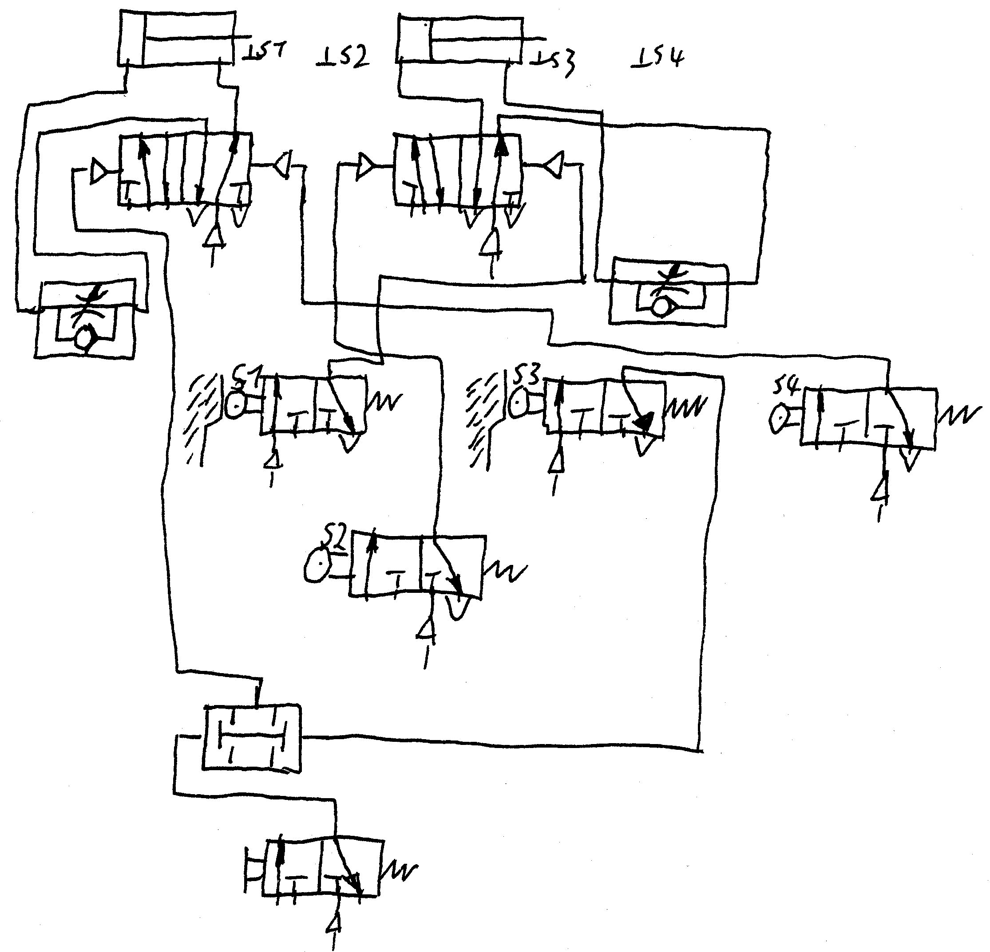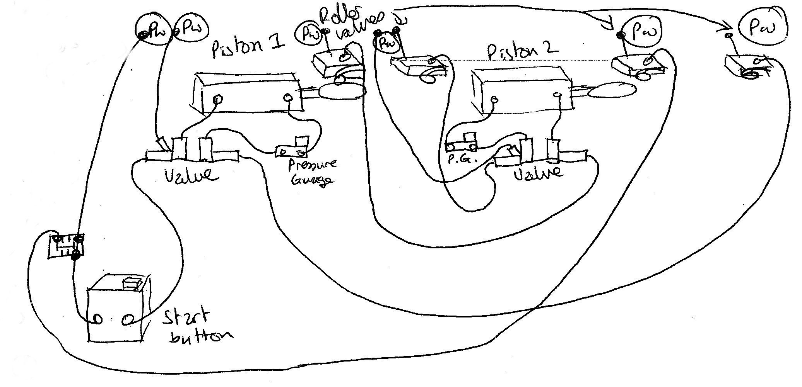
Left the drawing by a FluidSim student, right the drawing made by a CLEAR student
The FluidSim students made drawings very similar to the diagrams of FluidSim. The CLEAR student made a mixture between symbols and three dimensional pictures of the real components. The observation during the practical task showed that three students of the FluidSim group as well as four students of the CLEAR group drew a part of the circuit to solve the practical task. It helped the students to understand the connection and function of components. In the CLEAR group were several students who solved the task without a correct mental model. At the moment there is no theoretically based explanation for this effect.
Learning styles
The evaluation was unable to determine any link concerning the influence of learning styles, learning environments and learning output.
Usability of CLEAR
The users were asked to rate the usability of CLEAR. The analysis was divided into two parts: an informal questioning about the usefulness and the usability of certain system modules, and a standardised questionnaire to evaluate the usability according to ISO 9241 usability standards. Though in the interviews the students mention some negative aspects like the unreliability of the prototype, the rating in ISO questionnaire was all in all good. This allows the conclusion that there are some features that need to be improved, whereas the general user interface design was found appropriate.

Conclusion
The outcome of the evaluation is a rich set of data about the use of a new kind of learning environment in real courses. Beyond the results reported here, this will be a starting point for new research on this complex issue. For the development of CLEAR the results are valuable because they give direct feedback on what was created and what will be further developed in the future.
In addition, a method for evaluating computer based training systems was created and tested in practice. A variety of instruments are now available and can be adapted for the evaluation of other new systems or even existing products. During various meetings it was discussed if such evaluation approaches can be standardised. Though this discussion will take much more time, the BREVIE approach might serve as a model for other research projects.

Product Commercialisation
The commercialisation of the BREVIE project results was one of the main project tasks. This task was defined in an own work package, and the main contributors were the partners Virtual Presence, Festo and ARTEC.

At first, the legal prerequisites for a commercial exploitation were clarified. In a consortium agreement a consensus about the legal relationships in the project was defined and ratified. In the main, this agreement defines the access rights of the partners to the project results during and after the project time. In addition to the legal matters, the agreement is a kind of business policy of the project. It trims the project to the education and training market and identifies partner Festo Didactic as the ‘Principal Commercial Partner’ meaning that Festo will have the best chances to directly exploit the project results because of its strong position in this market. The business chance of the other partners is to support Festo in establishing new products and to make further developments or to provide services for Festo in the post-project phase.

Product Definition
As described earlier in this document, there are a wide range of innovations and technical developments. To become more concrete about the exploitation possibilities it was necessary to identify the best candidates for a commercialisation. The basic idea was to define a set of modules which will constitute the CLEAR ‘product family’.
The CLEAR product family will be a set of interoperating scalable products which fit customers’ needs for creating individual teaching and learning environments. CLEAR+, the baseline product (in essence the core software environment), is a state-of-the-art medium for computer based training with a range of user-friendly functionalities (including edited engineering drawings, multimedia component libraries, simulation components, 3D editing features, etc.). CLEAR++, the advanced product, combines computer-based training with traditional laboratory equipment. The CLEAR++ product package contains the CLEAR+ system and advanced components such as the hardware construction kit (HCK), an interface for integrating the physical and virtual circuits and the automatic 3D circuit generation capability, based on physical circuits. For both CLEAR products, there is an optional Web plug-in for interactive Internet access. In addition to the software and hardware products the offer will also contain the courseware developed in the BREVIE project.
As a direct result of the architecture underlying the CLEAR product family, customers will be able to modify and expand their individual CLEAR configuration for different vocational training subjects, such as hydraulics. As a simple illustration, and using the product classification given below, the core product (eg. CLEAR+ Pneumatics) can be upgraded to a more advanced training version (ie. CLEAR++ Pneumatics), or extended, as soon as available, with the CLEAR+ Hydraulics upgrade.

Marketing Strategy
As the near-horizon market to be targeted for the CLEAR product family falls within the sphere of activities of the Principal Commercial Partner Festo, the company has produced an initial financial breakdown. Festo estimates a world-wide market for certificated educational qualification in automation technology generally to be around 150 million Euro. Based on the historical sale of licences of Festo’s own products (pneumatics construction kit and FluidSim), Festo predicts an initial user sales group size of 10,000. Fixed (65 kEuro.) and marketing (35 kEuro.) costs have been identified, as have turnover figures (with costs of sale) for a 3-year timeframe.
The project has analysed the chances for bringing the innovative CLEAR product on the education & training market. The business opportunities have been described in a document and will have to be put in concrete terms in the post-project phase. Based on experiences with comparable product prototypes, for example stemming from VR community, it was recognised that the marketing strategy for CLEAR should consider its early stage where quality and safety accreditation is still missing. Instead of launching a big campaign the CODEPT-approach (COntrolled Distribution for the Evaluation of Prototype Technology) seems to be more promising for exploiting the project outcomes. This is an intermediate step between only disseminating ideas or concepts and full exploitation. European commercial and academic organisations will be encouraged to integrate the BREVIE/CLEAR project outcomes within their business or institution (on the basis of discounted evaluation licences with IPR protection for the CLEAR team). For example, commercial organisations enrolled in a CODEPT-Programme could use licensed systems for basic evaluation, in-house education, even selection and training of new recruits. In this way, annual market costs and risks to Festo can be kept to a minimum and the existence and benefits of the product are diffused more freely throughout the target community.
The overall responsibility for CLEAR license generation and distribution falls to the Consortium’s Principal Commercial Partner, Festo, who will, as part of normal business practice, market the CLEAR product family on behalf of the other partners. After the first 6 months of marketing activity (or longer, depending on prevailing market conditions), Festo will report back to the other commercial partners via artec at the University of Bremen, indicating how well the CLEAR concept and prototype product has been received by the automation technology community.

Conclusions and Future Plans
The BREVIE project made a significant contribution to the important social challenge of educating young people at vocational training schools or colleges. Automation technology in the industrial production becomes more and more complex, and needs skilled people who can develop, control and maintain them.
Based on pre-project scientific results and systematic user participation within BREVIE a new training concept for the basic automation technology subject ‘pneumatics’ was developed. The core of the project is the BREVIE learning environment (later called CLEAR) which supports the pedagogical idea of combining physical and virtual representations of pneumatic components, symbols, diagrams and circuits. With this vision and very early prototypes in their minds, the project partners created a complete course in basic pneumatics and they developed an evaluation procedure for getting scientific insight to the impact the technology has on learning.
In parallel to this proof-of-concept, which was designed to maintain the ability to modify the project plan during the project lifetime, the economic viability was investigated. Thanks to the presence of partner Festo in the education and training market and the experiences of partner Virtual Presence with innovative (VR)-products it was possible to specify the opportunities for a commercialisation of the project results. Considering the pre-product status of CLEAR, a smooth diffusion of the product in the education and training community seems to be the best way to introduce such an innovative technology and concept. This diffusion must take place in the near future, that is, in the post-project phase. Because of Festo’s intention to make business out of the project results, and based on the constructive co-operation during the project, there are real plans for some ARTEC team members to found a spin-off company for the further development of CLEAR (and some other business).
To draw a conclusion, it can be said that BREVIE was successful from a scientific point of view. It can also be said that the results achieved in BREVIE build a good basis for future commercialisation activities like the enhancement of the Festo product line and the foundation of a new technology company. However, the business opportunities are projections from an existing pre-product stage to the (hopefully near) future.

Contact Details
Project Partners
Prof. Dr. Wilhelm Bruns
University of Bremen (Co-ordinator)
Forschungszentrum Arbeit - Umwelt - Technic (artec)
Enrique-Schmidt-Str. 7 (SFG)
D-28359 Bremen, Germany
Tel.: +49 (0) 421 218-4206, Fax.: +49 (0) 421 218-4449
email: bruns@artec.uni-bremen.de, web: www.artec.uni-bremen.de

Dr. Ulrich Karras
Festo Didactic GmbH & Co.
Rechbergstr. 3
D-73770 Denkendorf, Germany
Tel.: +49 (0) 711 3467-334, Fax: +49 (0) 711 3467-355
email: dka@festo.de, web: www.festo.com

Ms. Karen Evans
Superscape plc
Bartley Wood - Buiness Park
Hook-Basingstoke, UK-ARG279XA, UK
Tel.: +44 1256 745-745, Fax: +44 1256 745-777
email: kevans@superscape.com, web: www.superscape.com

Prof. Robert Stone
Virtual Presence Ltd.
The Canvas House, Jubilee Yard, Queen Elizabeth Street,
London SE1 2NL, UK
Tel.: +44 161 969-1155, Fax: +44 161 969-1166
email: r.stone@vrsolns.co.uk, web: www.vrweb.com

Dr. Ian Hadfield
Stockport College of Further and Higher Education
Department of Engineering Technologies
Wellington Road South
SK 1 3UQ Stockport, Cheshire, UK
Tel.: +44 161 958-3256 / 3203, Fax: +44 161 958-3208
email: Ian.Hadfield@stockport.ac.uk, web: www.stockport.ac.uk

Mr. Ger van Hoving
Friese Poort Drachten
Leidijk 49
NL-9200 AA Drachten, The Netherlands
Tel.: +31 512 585-777, Fax: +31 512 585-740
email: drachten@friesepoort.nl, web: www.friesepoort.nl

Mr. Paulo Gata Amaral
Escola Superior de Tecnologia e Gestao
IPL
Morro do Lena
PT-2400 Leiria, Portugal
Tel.: +35 1 44 82 03 46, Fax: +35 1 44 82 03 10
email: pgata@estg.iplei.pt, web: www.estg.iplei.pt

Mr. Hermann Gathmann
Schulzentrum Im Holter Feld
Im Holter Feld 24
28309 Bremen
Tel.: +49 (0) 421 218-4836, Fax.: +49 (0) 421 218-4449
email: gathmann@artec.uni-bremen.de, web: www.schule.bremen.de/schulen/holterfeld

Prof. Gudela Grote
ETH Zürich
Institute for Work Psychology
Nelkenstr. 11
CH-8092 Zürich, Switzerland
Tel.: +41 1 632-7086, Fax: +41 1 632 - 1186
email: grote@ifap.bepr.ethz.ch, web: www.ifap.bepr.ethz.ch

Project URL
www.brevie.uni-bremen.de

Time Scale
Start: 1. January 1998, End: 31. March 2000, Duraction: 27 months

Budget
Overall cost: 2 357 549 Euro, European Commission contribution: 1 561 604 Euro

Final Report

Contact address for the Project:
Name: Prof. Dr. F. Wilhelm Bruns
Company: University of Bremen, artec
Street: Enrique-Schmidt-Str. 7 (SFG)
City: 28359 Bremen
Country: Germany

Telephone: +49 421 218-4206 / -7307
Fax: +49 421 218-4449
E-mail: bruns@artec.uni-bremen.de
WWW: http://www.brevie.uni-bremen.de

The Project (BREVIE, Bridging Reality and Virtuality with a Graspable User Interface) has been supported by the European Commission under the auspices of the TELEMATICS APPLICATIONS Programme.

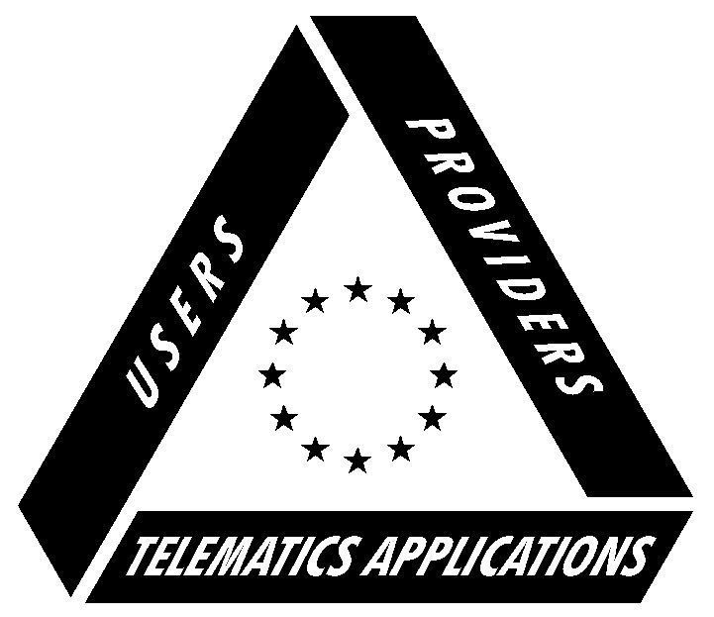

Further information on the TELEMATICS APPLICATIONS Programme:
You can obtain more information on the projects of the TELEMATICS APPLICATIONS Programme from:

European Commission, DG XIII, C/1
TELEMATIC APPLICATIONS Programme Information desk
Rue de la Loi 200 - BU 29 - 04/05
B - 1049 Brussels
Fax: +32 2 295 23 54
E-mail: telematics@dg13.cec.be
Or on the TELEMATICS APPLICATIONS Programmes’ homepage:
http://www.echo.lu/telematics

© The BREVIE Consortium, November 2000

